**Project Plan, Team Charter**

**TopFit – Workout and Wellness**

**“Group 11”**

|  |  |
| --- | --- |
| Industry Partner | Group 11 |
| Primary Instructor | Anjana Shah |
| Team Member | Nadezhda Mokhireva |
| Team Member | Vladyslav Bordiug |
| Team Member | Mahdi Esmaeelpour |
| Team Member | Parisa Khataei |
| Team Member | Muhammad Talha Sultan |

**Document Revision History**

|  |  |
| --- | --- |
| Revision # | Date |
|  |  |

Table of Contents

Executive Summary 3

Project Approvers, Reviews and Distribution List 3

Scope 4

Deliverables 4

Assumptions 6

Dependencies 6

Risk Management 8

Communication 9

Task Listing (WBS- Work Breakdown Structure) 10

Gantt Chart 11

Milestones 11

RAM – Responsibility Assignment Matrix 11

Approval 12

TEAM CHARTER 13

Purpose 13

Background 13

Scope 14

Team composition 15

Team empowerment 15

Team operations 16

Team Performance Assessment 17

Signature Page 17

# **Executive Summary**

The following describes the project to be executed.

|  |  |
| --- | --- |
| **Objective** | The primary purpose of this Project Plan is to define the key components of the *TopFit* application. The product will be designed to encourage users to obtain a healthy lifestyle as this is often an issue due to the lack of time and high related expenses. Project Plan will assist in establishing expectations and reducing risks. This document also serves as an agreement among all parties involved in *TopFit* application development. |
| **Corporate Goals Addressed** | * Expand the company’s market share * Commit to the community * Enhance customer satisfaction and in this way improve the company’s reputation * To raise the company’s budget |
| **Planned Start Date** | Monday, September 23, 2019 |
| **Planned End Date** | Friday, March 27, 2020 |

# **Project Approvers, Reviews and Distribution List**

Approvers, reviewers and distribution list

|  |  |  |  |
| --- | --- | --- | --- |
| **Project Role** | **Name** | **E-mail** | **Date** |
| Back-End Developer, Project Leader | Nadezhda Mokhireva | nadezhda.mokhireva@georgebrown.ca | October 3rd, 2019 |
| Front-End Developer, UI Designer | Vladyslav Bordiug | vladyslav.bordiug@georgebrown.ca | October 3rd, 2019 |
| Back-End Developer, Database Admin | Mahdi Esmaeelpour | mahdi.esmaeelpour@georgebrown.ca | October 3rd, 2019 |
| Developer, Tester | Parisa Khataei | parisa.khataei@georgebrown.ca | October 3rd, 2019 |
| Developer, Tester | Muhammad Talha Sultan | muhammadtalha.sultan@georgebrown.ca | October 3rd, 2019 |

# **Scope**

|  |  |
| --- | --- |
| **In Scope** | **Out of Scope** |
| Record user’s physical activity based on GPS tracking | Access to diet and nutrition information |
| Synchronize with the user’s calendar to automatically schedule workouts at available times | Personal training |
| Send the user notifications / reminders about upcoming exercise sessions | Communication among users within the application |
| Store personal statistics and display the user’s progress | Spam emails |

# **Deliverables**

|  |  |
| --- | --- |
| **Deliverable** | **Description** |
| Variable workout length | User will be able to choose a workout length that fits their lifestyle. After that, only the selected portion of database will be accessible; users can change their choice any time. |
| Visual Exercise Guide | Graphical interface with visual representation of the exercise technique as well as the text instructions |
| Free Download | Use of free technologies and software allows for the application to be released at no cost – there’s no need to charge for downloading |
| Automatically Estimated Workout Intensity | User will be able to record their body measurements and desired goals. Based on the entered data, workout intensity will be estimated and suggested. User will have an option to modify both the measurements and the intensity any time. |
| Notifications | A scheduled task will run to notify users about their upcoming workouts. |
| Flexibility of Exercise Places | The exercises that make up the application content will not require any equipment or special arrangements and thus can be completed from any place |
| Individual Workouts | All the workouts can be completed individually |

# **Assumptions**

In order for the project to move forward according to the plan, the following elements should be present:

**Resources**

* Users will be able to test the Beta-version of the product at the agreed time
* Hardware used by developers will be properly configured (all the necessary software present and functional)
* Estimated development time and cost are not exceeded
* The necessary training for developers will be conducted independently with no additional expenses

**Solution**

* The first release of the application will be free of charge and available for download for Android OS phones
* All the defined functions will be implemented and working without interruption

**Scope**

* Project scope will remain consistent after the scope statement is signed by the involved parties

**Methodology**

* Project will follow agile methodology throughout the development cycle, with every sprint delivering all the defined outcomes

**Technology**

* The primary technology used for development will be the Java programming language.
* Android Studio will be used as the IDE.
* Alpha-testing will be conducted on developers’ own devices, while beta-testing will take place of testers’ Android phones.

# **Dependencies**

**Internal**

* Workouts are complete sets of exercises
* All workouts are safe to perform
* User accounts are well-protected from external access
* Application content receives positive feedback from users
* Content is periodically reviewed and renewed.

**External**

The success of the project is greatly dependent on the market demand for fitness applications.

* Opening of a big number of fitness facilities in a city will make them more accessible that might decrease the demand for the *TopFit* application
* If prices for gym membership decrease, customers are likely to choose a traditional way of exercising over using the application.

The project also depends on competitors’ success:

* If a similar application with more features is released by a competitor company, market share might change in favor of the competitors.
* On the opposite, if no significant activity is performed by other companies, *TopFit* might eventually dominate the market.

# **Risk Management**

|  |  |  |  |
| --- | --- | --- | --- |
| **Potential Risk** | **Severity (H/M/L)** | **Likelihood (H/M/L)** | **Management Strategy** |
| Power shutdown while development in progress | L | L | Having a backup for all code; having another location to conduct development |
| A team member quits the project | H | L | Invite another developer |
| Hardware failure | M-H | L | Have a backup piece of hardware for replacement |
| Assumption invalidated | M | M | Allocate enough time within deadline to resolve the issue |
| Unable to implement a feature | M | M | Consult a senior developer |
| Failure to meet a requirement | M | M | Offer an alternative solution for that specific requirement, re-evaluate priorities |
| Security risk | M | M | Review and apply industry standards, switch to a different technology |

# **Communication**

**Reporting**

The following reports are produced:

|  |  |  |
| --- | --- | --- |
| Report | Audience | Frequency |
| T27_High_Level_Requirements.docx | Team 27 members | One time |
| Minutes of Meeting | Team 27 members | weekly |
| T27_Project_Summary.docx | Team 27 members | One time |
| T27_User_Product_Backlog.docx | Team 27 members | One time |
| T27_User_Stories_Personas.docx | Team 27 members | One time |
| T27_Project_Vision.docx | Team 27 members | One time |

**Meetings**

The following meetings/communication are established:

|  |  |  |  |
| --- | --- | --- | --- |
| Meeting | Purpose | Attendees | Frequency |
| Minutes of Meeting 1 | Review the progress of sprint 1; make necessary adjustments to work division among members. | Parisa Khataei, Talha Sultan, Mahdi Esmaeelpour, Nadia Mokhireva and Bordiug Vladislav | One time |
| Minutes of Meeting 2 | Prepare to start sprint 2; review the expected outcomes and assign the tasks to team members. | Parisa Khataei, Talha Sultan, Mahdi Esmaeelpour, Nadia Mokhireva and Bordiug Vladislav | One time |
| Minutes of Meeting 3 | Check up on everyone’s progress to ensure that no delay are going to take place. | Parisa Khataei, Talha Sultan, Mahdi Esmaeelpour, Nadia Mokhireva and Bordiug Vladislav | One time |

During the off-meeting hours, communication is maintained via instant messaging.

# **Task Listing (WBS- Work Breakdown Structure)**

The following resource proposal template summarizes the resource hours committed to this project, upon final approval of this document.

|  |  |  |  |
| --- | --- | --- | --- |
| Reference | Tasks | Duration | Dependency |
| Nadezhda Mokhireva | Completing the Project Plan (Executive Summary, Project Approvers, Reviews and Distribution List, Scope, Deliverables, Assumptions, Dependencies, Risk Management sections) | 3.5 hours | Documentation for sprint 1 and 2 |
| Parisa Khataei | Maintaining the Minutes of meeting documentation, monitoring the progress of tasks | 2 hours | Every member’s work progress |
| Muhammad Talha Sultan | Preparing the questions for the instructor based on the issues team members had while completing their tasks | 1.5 hours | Every member’s work progress |
| Vladyslav Bordiug | Completing the Product Backlog and the Sprint Backlog | 2 hours | Sprint 1 outcomes |
| Mahdi Esmaeelpour | Completing the Project Plan (Communication, Task Listing (WBS- Work Breakdown Structure), Gantt Chart, Milestones, RAM – Responsibility Assignment Matrix, Approval sections) | 4 hours | Minutes of meeting and tasks assignment |

# **Gantt Chart**

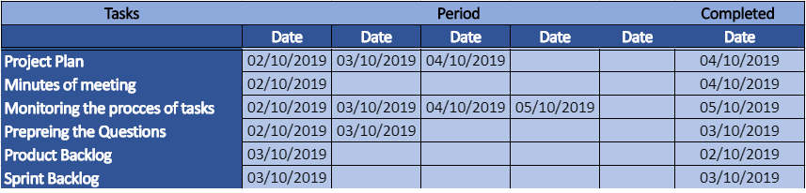

# **Milestones**

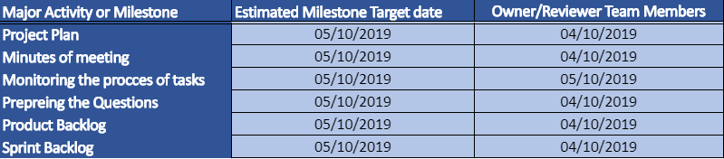

# **RAM – Responsibility Assignment Matrix**

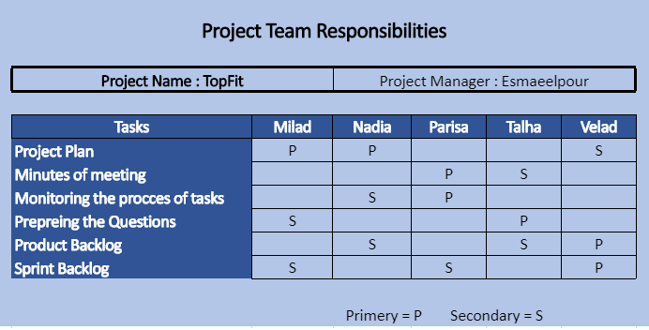

# **Approval**

The signatures below indicate their approval of the contents of this document.

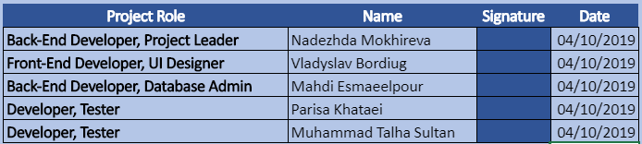

# **TEAM CHARTER**

## **Purpose**

This team has been formed to complete the development of *TopFit* application as the deliverable of the Capstone course. The team members’ main purpose is to persist the course material. The achievement will be demonstrated during the final presentation; with an opportunity for the instructor and fellow students to ask any project-related questions.

## **Background**

**Project Summary**

*TopFit* application developed by *Group 11* allows users to schedule workouts and get reminders, track their activity and get advice on healthy habits. The AI-driven engine enables custom settings that will fit every user’s needs. *TopFit* can be installed on an Android device and is supported by a wide range of OS versions.

**Team within Organization**

The organization the team belongs to supports agile development methodology. Because of this, the team works in short sprints, each 2 weeks long. Some of the team members work closely with the organization’s authorities, which allow them to see the project from a different perspective and make their contributions accordingly.

**Users of the Project**

*TopFit* primarily targets the following categories of users:

* People with sedentary lifestyle and
* People with lack of time to attend fitness facilities
* People who need to be home all day
* Unemployed people

To be more exact, the typical application users will be office workers, students and employees who work from home, including self-employed people.

**Special Circumstances**

* Project must be developed at no cost (as no budget was allocated)
* Team members are unfamiliar with the chosen development technology; it will be mastered in the process of creating the application

## **Scope**

**Project Scope**

The scope of the *TF* application is mainly defined by its primary functions:

* Record user’s physical activity based on GPS tracking
* Synchronize with the user’s calendar to automatically schedule workouts at available times
* Send the user notifications / reminders about upcoming exercise sessions
* Store personal statistics and display the user’s progress

Additional functionality might be developed, should the team have sufficient time and resources.

**Project Mission**

The project mission is to design an application with user-friendly interface and comprehensive content for people with different levels of fitness.

**Project Objectives**

* From users’ perspective, a high-quality application that will provide guidelines for exercising from home must be delivered.
* From the team’s perspective: advance and persist the knowledge of Android mobile application development; familiarize themselves with industry concepts and practices.

**Team Role**

The team will be fully responsible for developing the project. All the lacking knowledge should be compensated for with self-learning. In case an issue cannot be resolved, team members might contact the instructor for advice / assistance.

## 

## **Team composition**

The team consists of five members with diverse skillsets:

* Back-end Developer
* Front-end Developer
* UI designer
* Tester
* Database Administrator

Due to the small number of people on the team, all members are considered essential and must contribute to the project for it to be delivered on time. Because completing the Capstone course is part of the members’ curriculum, it is critical that everyone is putting a significant amount of time and effort towards succeeding in the project. The minimum requirement is to attend the lab sessions, lectures and Minutes of Meeting, with a total of approximately 5 hours a week.

## **Team empowerment**

**Within a team**, Nadezhda (Nadia) Mokhireva is an informal leader. She is responsible for organizing the work and being a good example for other team members. For her to succeed in her role, she must demonstrate excellent performance and commitment to the project, as well as great communication and time-management skills.

**Outside the team,** a higher level of authority is represented by professor Anjana Shah. Knowledgeable and experienced, she is to be consulted for any issues that cannot be resolved within a team.

## **Team** **operations**

**Decision-Making Process**

When a decision is being made, all members’ opinions must be taken into consideration. At the end of the discussion, every participant is encouraged to provide constructive feedback. Once the consensus is reached, a meeting is considered successful and can be terminated.

**Handing Issues**

Should an issue arise, team members must attempt to resolve it peacefully and objectively. It is important to stay respectful to every other member and considerate under pressure. If a problem cannot be solved within the team, it is recommended to contact the instructor.

**Expectations**

Meetings – every member is expected to attend the meetings or notify the team if they will be absent. When the meeting is in progress, all team members should be engaged.

Contributions – contributions to the project should be evenly distributed among team members. If a person fails to deliver their part, they should be politely reminded of their duties during a one-on-one conversation.

General Code of Conduct – it is expected for every team member to stay polite and respectful even when disagreeing. Also, the use of offensive language is not supported; as well as any actions that can compromise / distress a team member.

**Communication**

Communication during off-meeting hours will be maintained via instant messaging and email, should a big data be delivered. A shared repository on GitHub was created to work collaboratively on project documents. In case the instructor needs to be contacted, a team member can perform it via college email.

**Meetings**

Each meeting will have distinct purpose. The steps and points to be discussed will be agreed upon before the meeting and will be documented in the agenda. Each team member is responsible for arriving on time, acting respectfully during the meeting and contributing to the discussion.

## **Team Performance Assessment**

Each meeting will be documented and analyzed from the effectiveness perspective. The main points of interest will be:

* Planned vs achieved during the meeting
* Interpersonal communication
* Problems discussed in the meeting (if any)

At the end of each sprint, progress will be reviewed against project deadlines in order to make timely adjustments.

## **Signature Page**

By signing this page, I agree to the contents of the documentation and to be held accountable for adherence and contributions:

Nadezhda Mokhireva

Muhammad Talha Sultan

Parisa Khataei

Mahdi Esmailpour

Vladyslav Bordiug